**LEBANESE AMERICAN UNIVERSITY**

**USAID – HIGHER EDUCATION SCHOLARSHIP PROGRAM**

**HES - Volunteering Program Verification Form**

This form is to be used to document volunteering hours. If a student volunteers for multiple organizations, a separate form must be used for each organization. **This form must be turned in by the 28th of each month, the latest.**

I certify that the scholar Maram El Shamaa completed a total of 5 hours of service at InnovaThrive.

The hours were completed hours as per the below:

Hours # 2 (date) _2/12 – 6/12_ (initials of supervisor) __A.K.___

Hours # 2 (date) _9/12 – 13/12_ (initials of supervisor) __A.K.___

Hours # 1 date) _16/12 – 20/12 (initials of supervisor) __A.K.___

Hours # 0 date) _23/12 - 27/12 (initials of supervisor) __A.K.___

Brief description of the activities the scholar performed or participated in:

Research Paper about AI in Detecting and Preventing Online Misinformation  
The reseach paper includes;  
-Definition:  
Exploring how AI identifies and mitigates the spread of fake news.  
-Technologies:  
NLP algorithms for fact-checking content.  
Machine learning models for identifying deepfakes.  
-Applications:  
Real-time flagging of misleading posts on social media.  
Educating users through AI-curated fact databases.  
-Statistics:  
Reduction in misinformation engagement by 30% using AI moderation.  
-Advantages:  
Improving the quality of information online.  
-Disadvantages:  
Risks of censorship and biases in AI systems.  
-Challenges:  
Developing unbiased datasets for training AI models.  
-Future Research:  
AI collaborations with media organizations for enhanced fact-checking.

Written feedback about the scholar’s performance:

Maram El Shamaa’s research on AI in detecting and preventing online misinformation was thorough and impactful. By highlighting AI’s role in combating fake news and deepfakes, Maram effectively addressed key technologies, challenges, and future collaborations, showcasing the significance of AI in ensuring accurate online information.

Please rate the overall performance of the scholar at your organization:

|  |  |  |  |
| --- | --- | --- | --- |
|  | Mastery (5) | Proficient (3) | Emerging (1) |
| **Problem solver** | X |  |  |
| **Engaged & Committed** | X |  |  |
| **Open-minded & multicultural** | X |  |  |

Signature

& stamp

__________________________

_

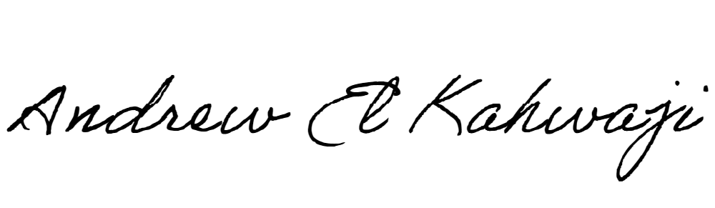

Printed Name _Andrew El Kahwaji_

Date __26/12/2024___

Email __andrew.lifesculptor.coo@gmail.com __

Phone __+961 71 914 378__